Glider Carmen update from Sunday, March 31 to Wednesday, April 3

The black dots represent the ESPs. The gliders passed the ESPs on the morning of Tuesday, April 2.

Rotated to show glider track from above.

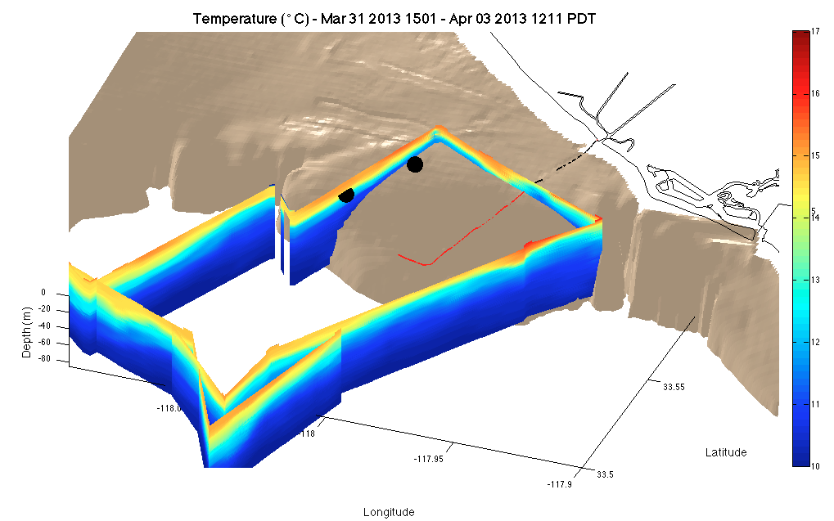

Profile from Sunday-Tuesday. The glider was passing the ESPs morning of April 2 after we saw the initial increase in DA and PN at the ESPs. The white line is the 25 kg/m3 isopycnal often associated with nutrient rich waters.

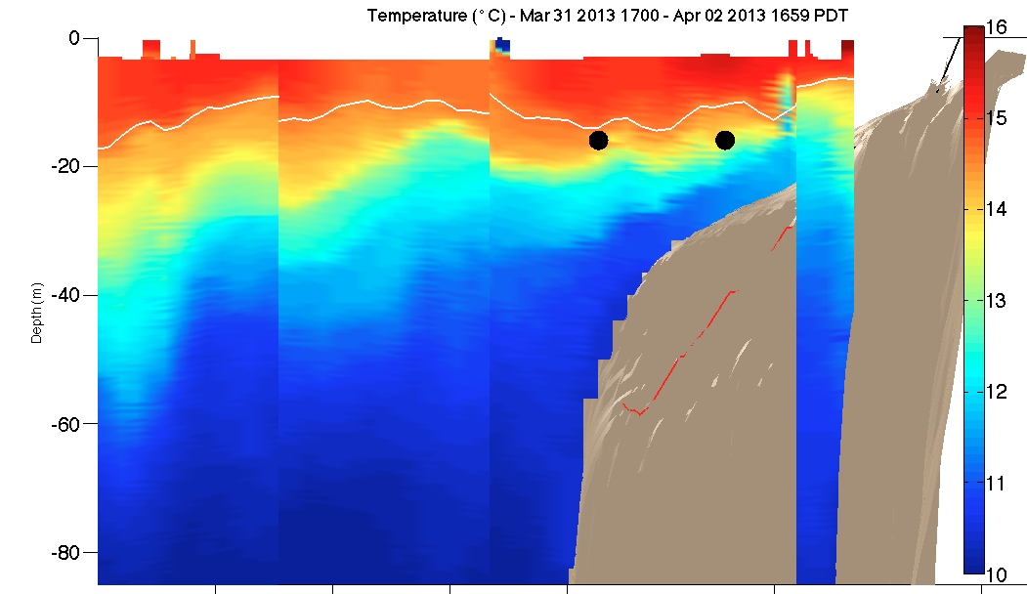

The chlorophyll data from the gliders show a connection between the subsurface and surface chlorophyll and the ESPs seem to be sitting in the middle.

